Lab: Functions
Problems for exercise and homework for the "JS Fundamentals" Course @ SoftUni.
Submit your solutions in the SoftUni judge system at: https://judge.softuni.org/Contests/1230/

Format Grade
Write a function that receives a grade between 2.00 and 6.00 and prints a formatted line with grade and description.
- < 3.00 - "Fail"
- >= 3.00 and < 3.50 - "Poor"
- >= 3.50 and < 4.50 - "Good"
- >= 4.50 and < 5.50 - "Very good"
- >= 5.50 - "Excellent"

Examples
Input | Output
3.33 | Poor (3.33)
4.50 | Very good (4.50)
2.99 | Fail (2)

Hints
- Use a series of if statements checking the threshold between grade brackets
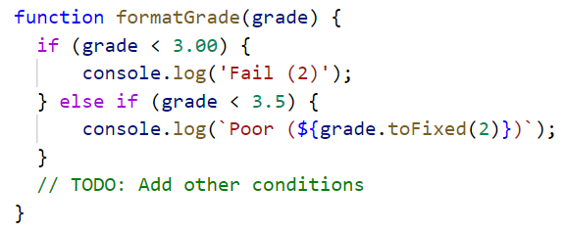

Math Power
Write a function that calculates and print the value of a number raised to a given power:

Examples
Input | Output
2,8 | 256
3,4 | 81

Hints
- Create a function that will have two parameters - the number and the power.
- Print the result to the console.

Repeat String
Write a function that receives a string and a repeat count n. The function should return a new string (the old one repeated n times).

Examples
Input | Output
"abc", 3 | abcabcabc
"String", 2 | StringString

Hints
- Use a loop or another method to repeat the input string.
- Use the return operator to produce the result.

Orders
Write a function that calculates the total price of an order and prints it on the console. The function should receive one of the following products: coffee, coke, water, snacks; and a quantity of the product. The prices for a single piece of each product are:
- coffee - 1.50
- water - 1.00
- coke - 1.40
- snacks - 2.00
Print the result formatted to the second decimal place.

Example
Input | Output
"water", 5 | 5.00
"coffee", 2 | 3.00

Hints
- Create a function and pass the two variables in.
- Print the result in the function.

Simple Calculator
Write a function that receives three parameters – two numbers and an operator (string) – and calculates the result depending on the operator. Operator can be 'multiply', 'divide', 'add' or 'subtract'. Try to solve this task using arrow functions.

Bonus
Solve this task without using any conditional statements (no if or switch statements or ternary operators).

Input
The input comes as parameters named numOne, numTwo, operator.

Examples
Input | Output
5,  5,  'multiply' | 25
40,  8,  'divide' | 5
12,  19,  'add' | 31
50,  13,  'subtract' | 37

Hints
- Use a switch statement for the different operators.

Sign Check
Write a function, that checks whether the result of the multiplication numOne * numTwo * numThree is positive or negative. Try to do this WITHOUT multiplying the 3 numbers.

Input
The input comes as parameters named numOne, numTwo, numThree.

Output
- If the result is positive, print on the console -> "Positive"
- Otherwise, print -> "Negative"

Example
Input | Output
5,  12,  -15 | Negative
-6,  -12,  14 | Positive
-1,  -2,  -3 | Negative
-5,  1,  1 | Negative

Hints
- Consider how the sign of each of the three input parameters will affect their product.
- Check all the different combinations for the three numbers.

